# ERD and conceptual schema for the "CoinBounce" full-stack application

# C:\Users\Madiha\Desktop\University_of_Engineering_and_Technology_Peshawar_logo.svg.png

**Spring 2023**

## Database Management System

### Submitted by:

**Name:** Hashir Asmat **Registration No:** 20PWCSE1896

**Name:** Nida Nizar **Registration No:** 20PWCSE1891

### Section: A

### Department of Computer Systems Engineering

### University of Engineering and Technology, Peshawar

**ERD of** “CoinBounce” Full Stack Application Development

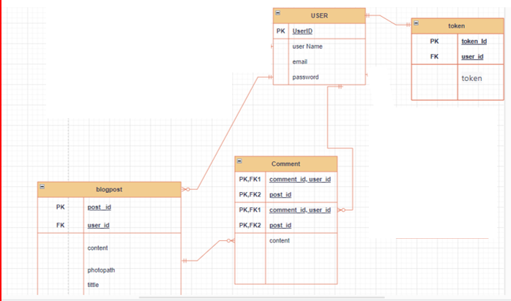

**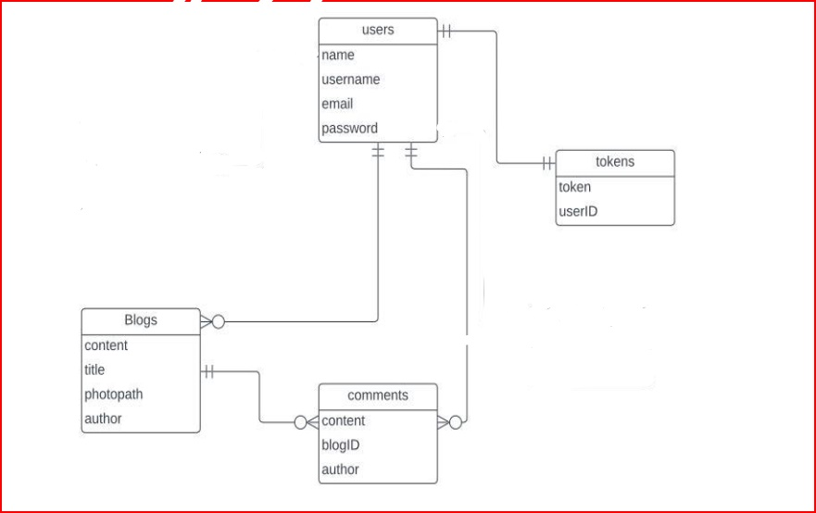**

**conceptual schema for the "CoinBounce" full-stack application:**

The conceptual schema for the "CoinBounce" full-stack application using the MERN stack would typically involve multiple components and entities. Here's a conceptual schema that outlines the main components and their relationships:

**1. User:**

* **Attributes:** user ID, username, email, password, profile information, etc.
* **Relationships:** Can have relationships with blog posts, comments, chat messages, and favorite cryptocurrencies.

**2. Blog Post:**

* **Attributes:** post ID, user ID (foreign key), content, date /time, etc.
* **Relationships:** Belongs to a user, can have multiple comments.

**3. Comment:**

* **Attributes:** Author or user ID ,post ID or blog ID (foreign key), contents etc.
* **Relationships:** Belongs to a user, belongs to a blog post, can have many replies.

**4. Token:**

* **Attributes:** token ,User ID
* **Relationships:** Belongs to a user, can have minimum and maximum one token.